BIT 4107 – Mobile Application Development
ENHANCED PROFESSIONAL STUDENT LOGBOOK
Student Name: Brian Mumo
Admission Number: BIT/2025/30082
School/Faculty: Computing and Informatics
Programme: Bachelor of Science in Information Technology (BSc IT)T
Academic Year: 2025/2026
Semester: THREE
Lecturer: MR MICHAEL NYORO
Phone Number:

Week 1: Introduction to Mobile Application Development

1.1: Practical Activities Undertaken (SCREENSHOTS)
1. Installation of Android studio
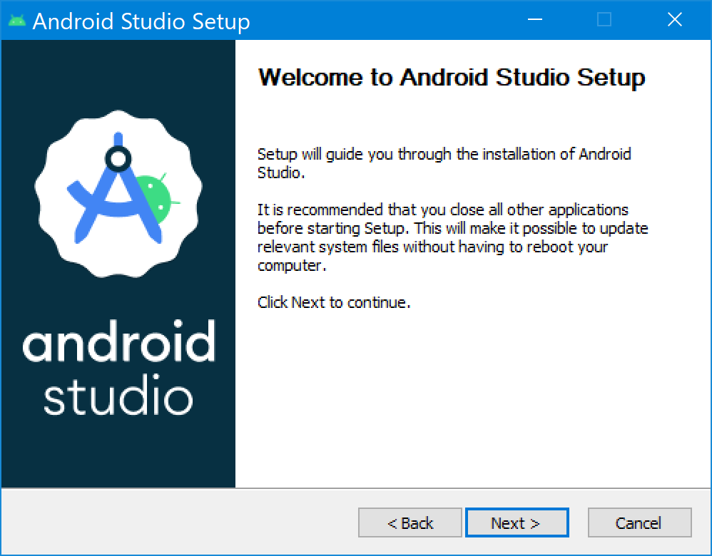
2. Installing Flutter and Dart Extensions in Android studio
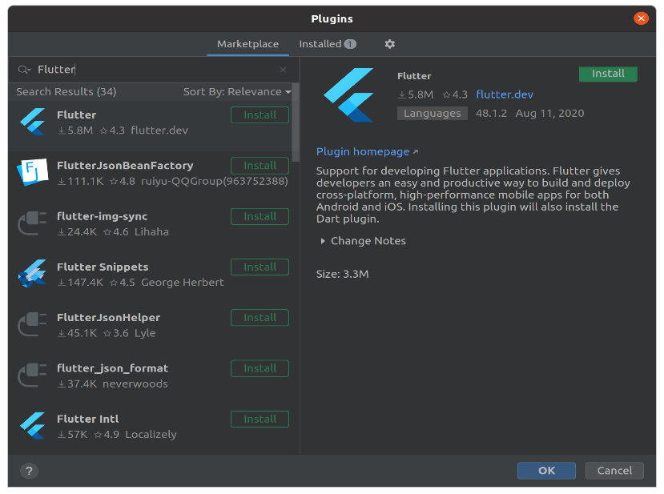
3. Verifying the Development Environment using Flutter Doctor
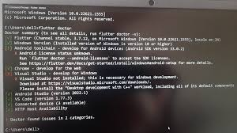
4. Creating the Flutter Project in Android studio
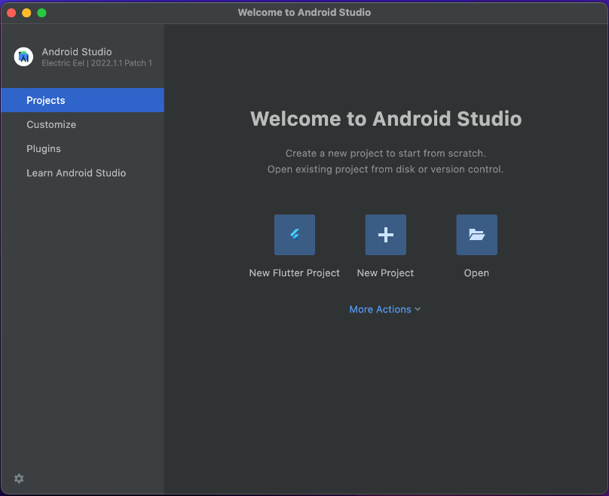

5. Source code of the flutter project
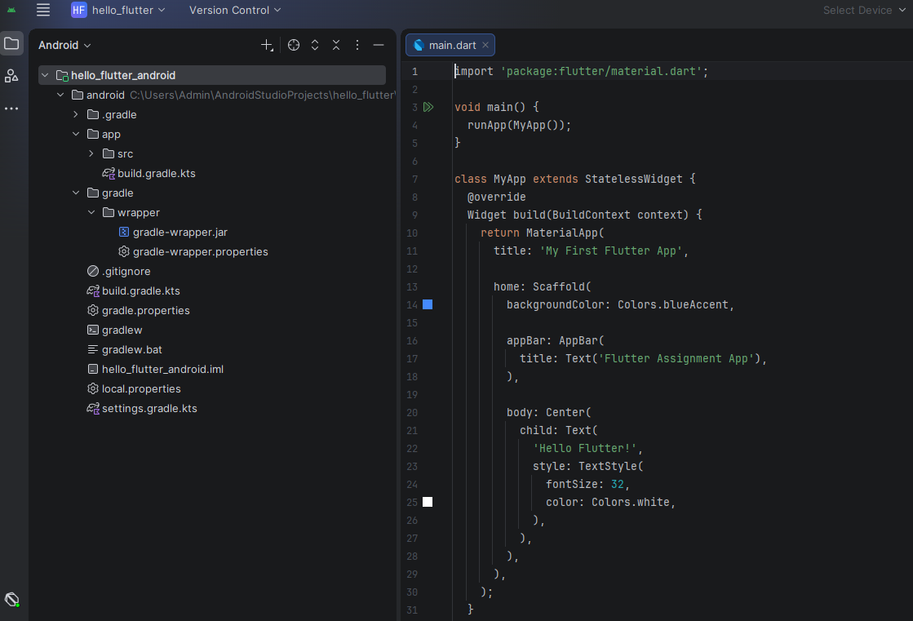
6. Final Outcome
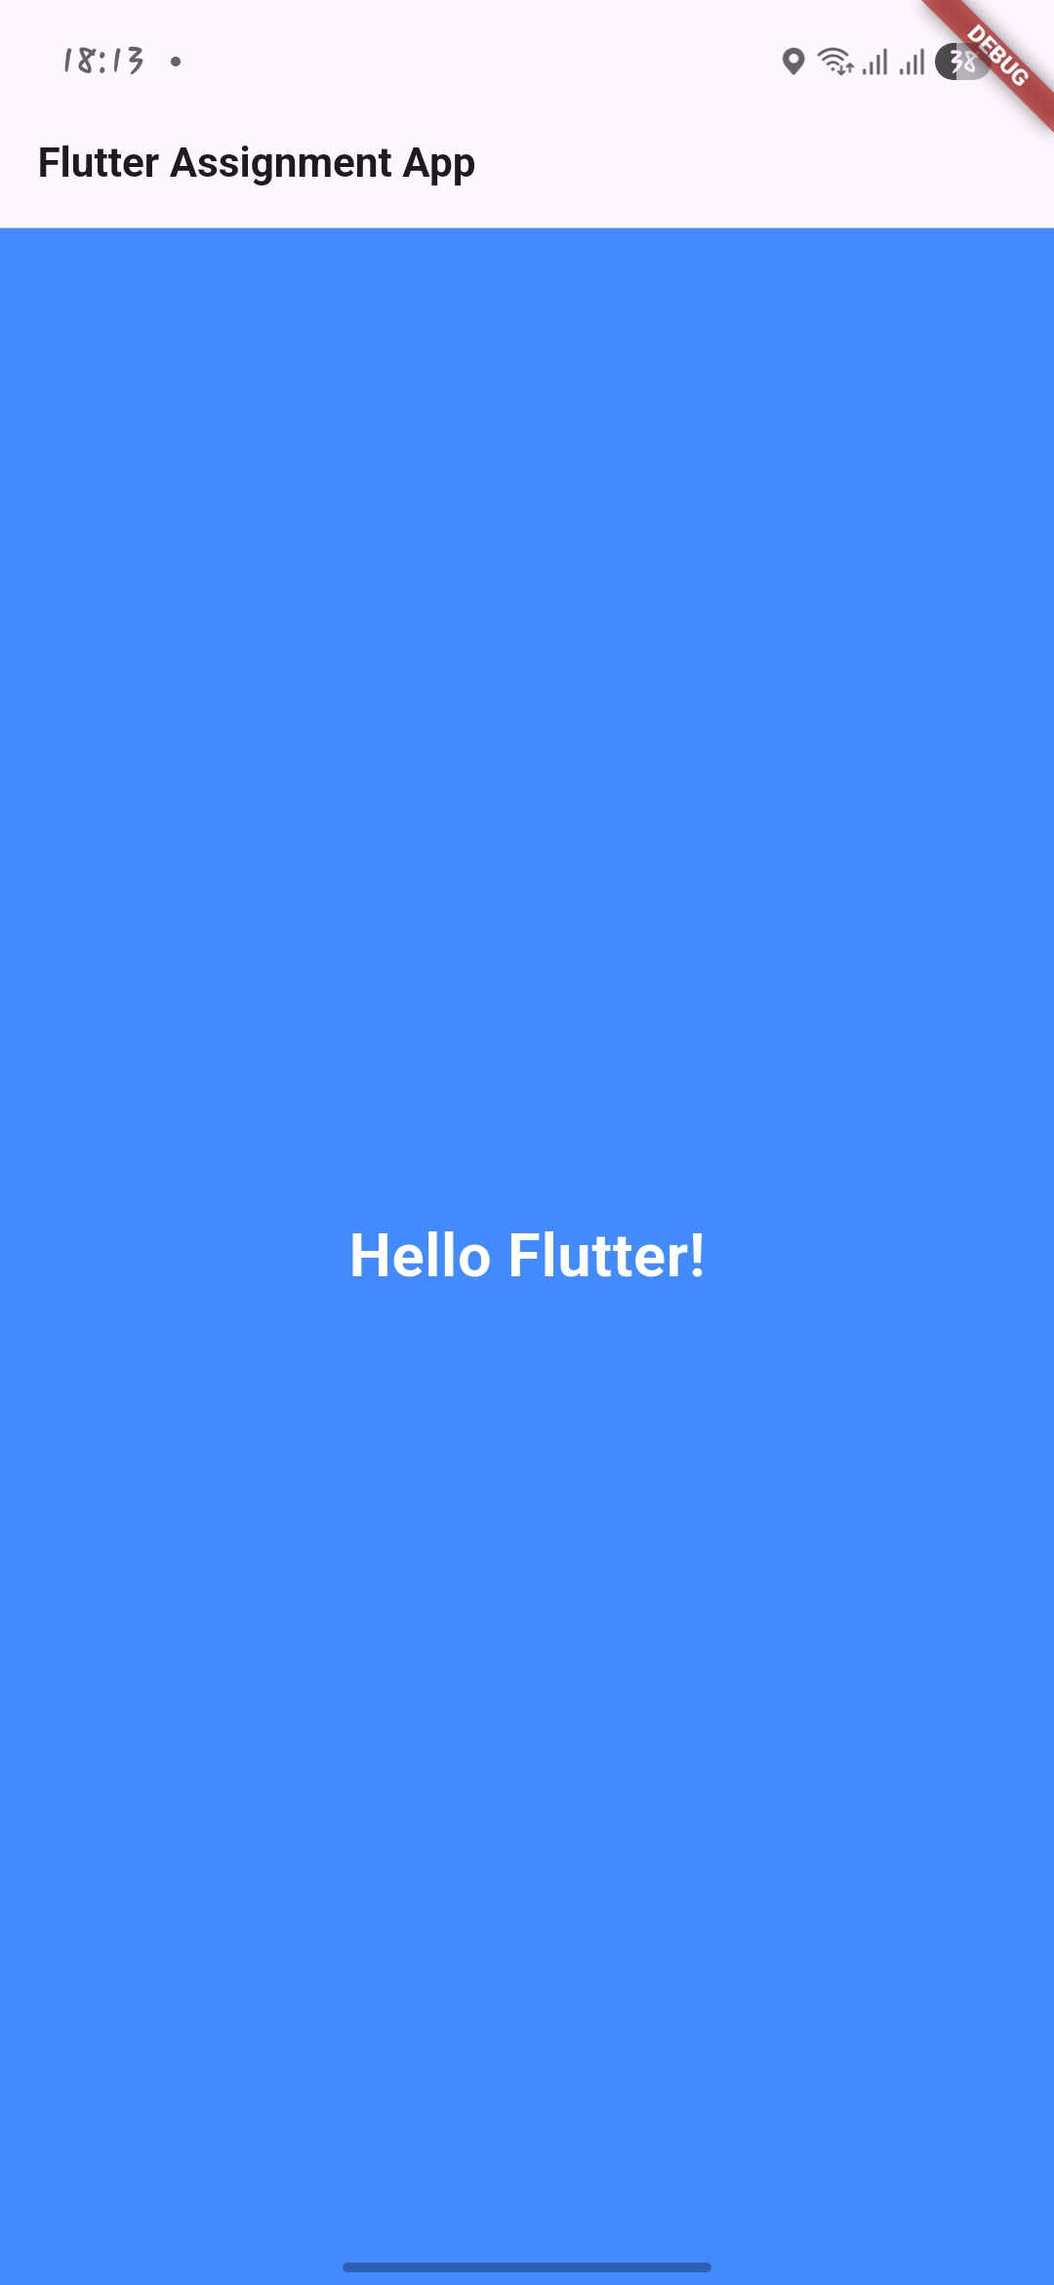

1.2: Tools/Software Used
The software is flutter extension inside android studio.

1.3: Personal Reflection
Creating my first Flutter app was a great learning experience. I learned how to create a Flutter project, run it on an emulator and a real physical device, and understand the basic structure of a Flutter application.Even though the app was simple, it helped me understand the fundamentals of Flutter development. This experience showed me that every big project starts with a small step. It has motivated me to continue learning Flutter and build more applications in the future.

Week 2: Mobile Development Environment

2.1: Practical Activities Undertaken (SCREENSHOTS)
1. Login Screenshot
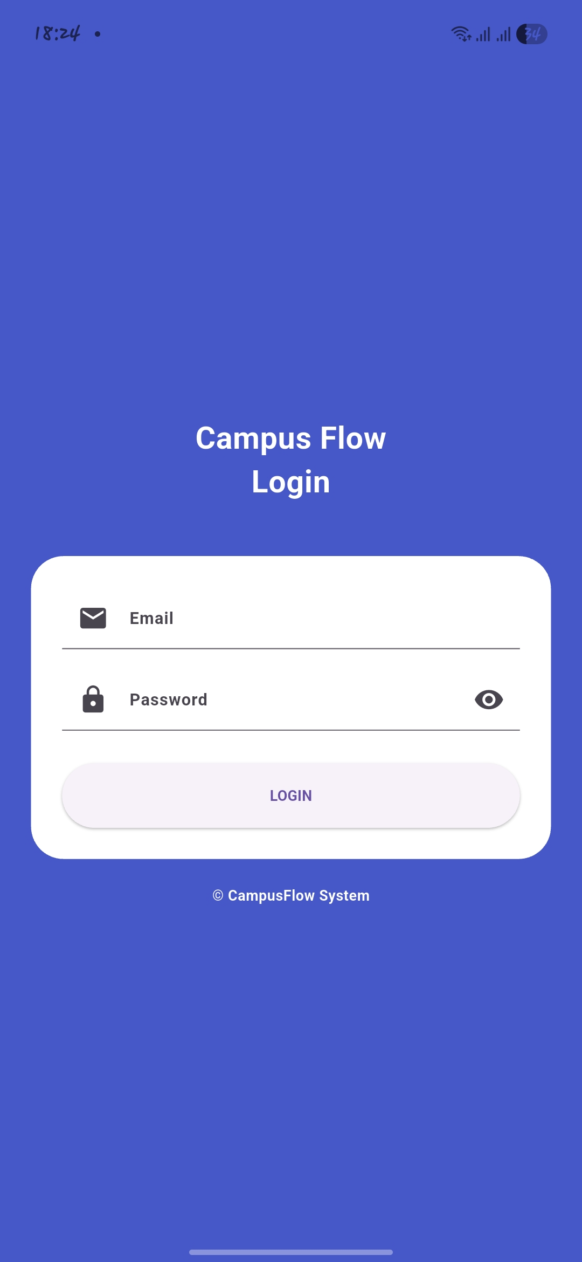
2: Dashboard Screenshot
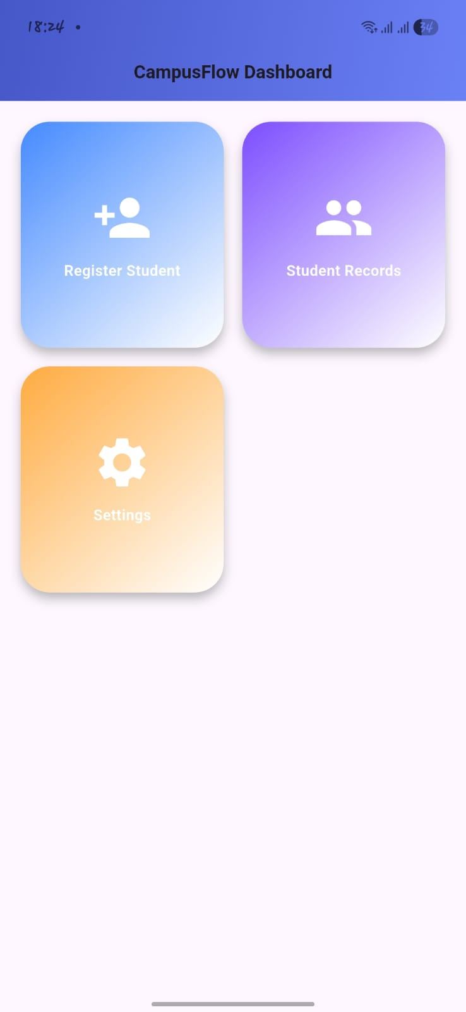
3. Registration Screenshot
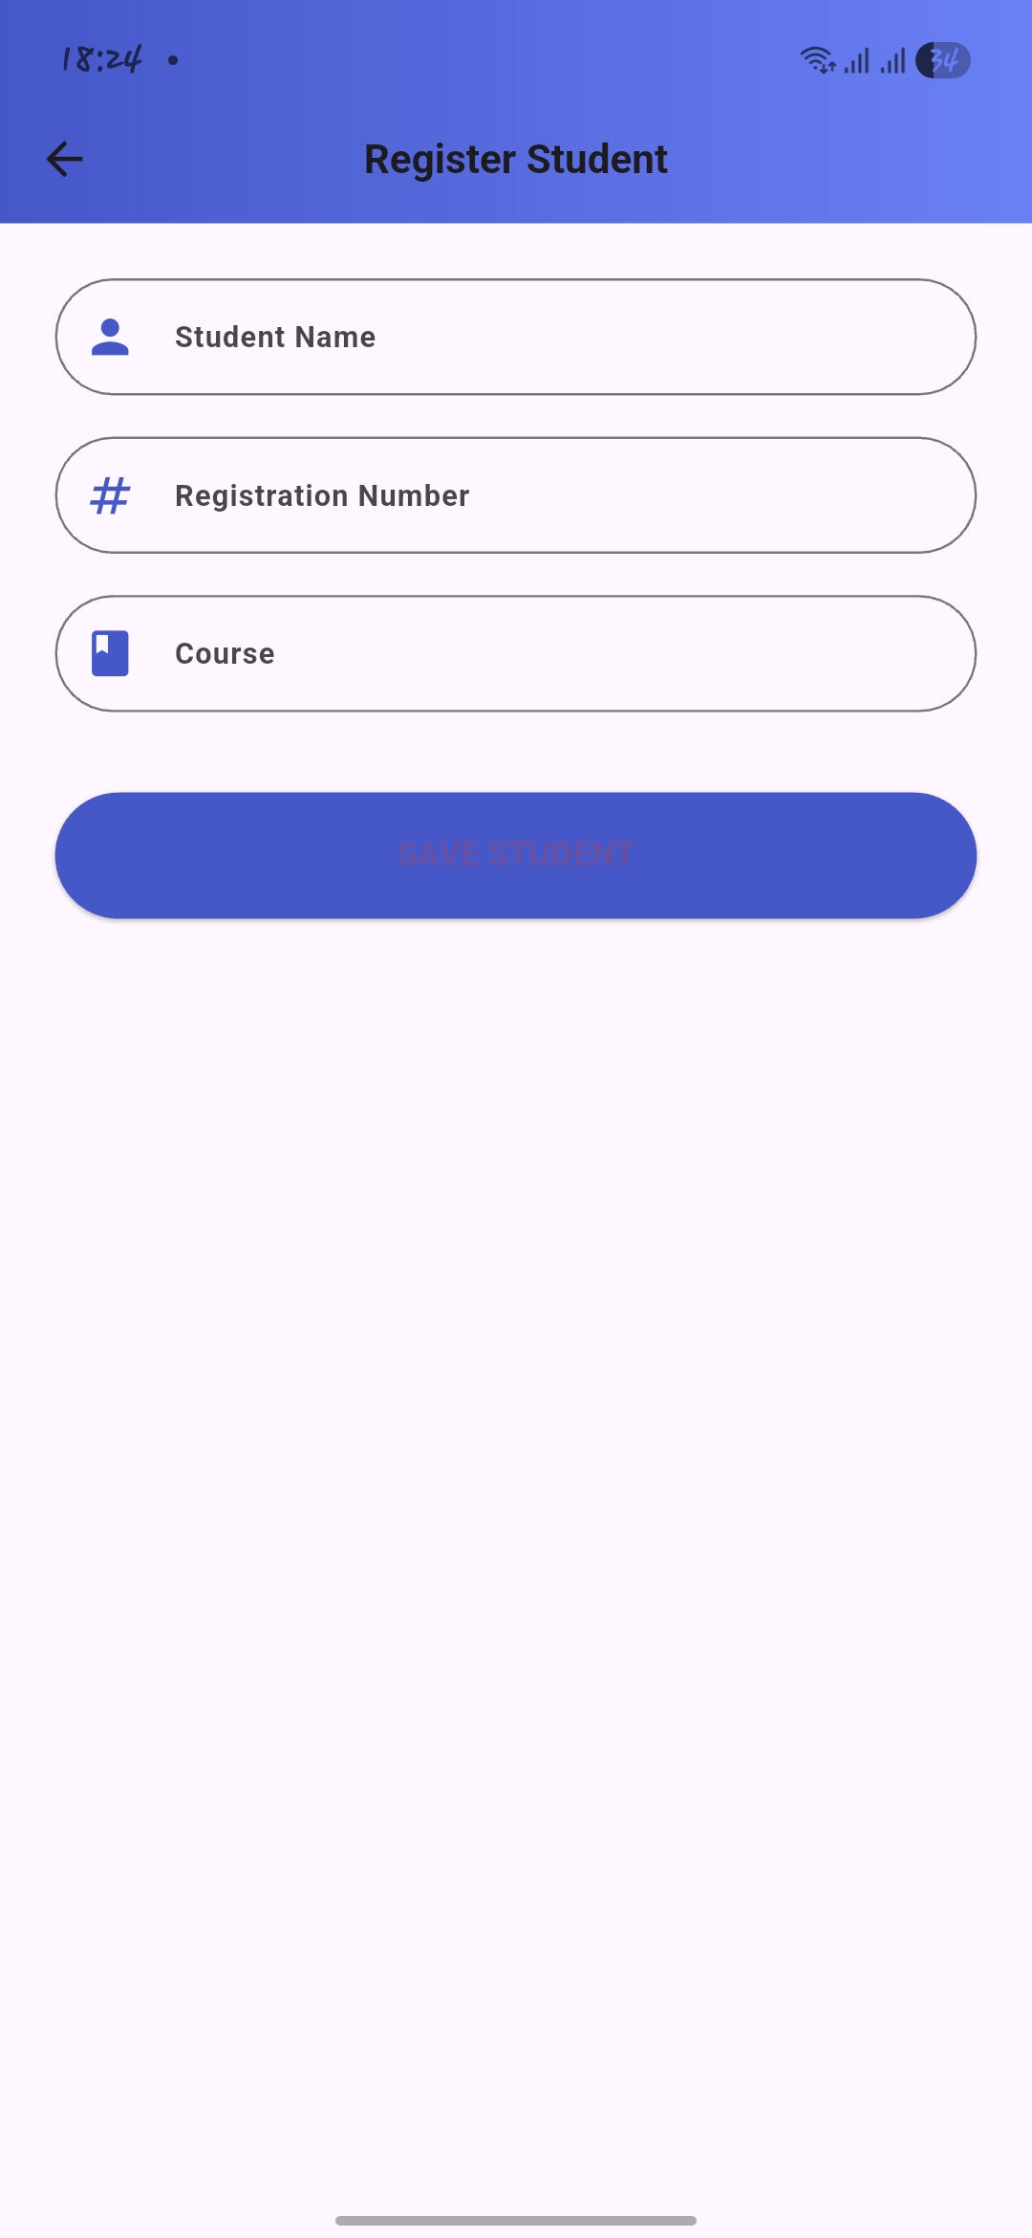
4. Records Screenshot
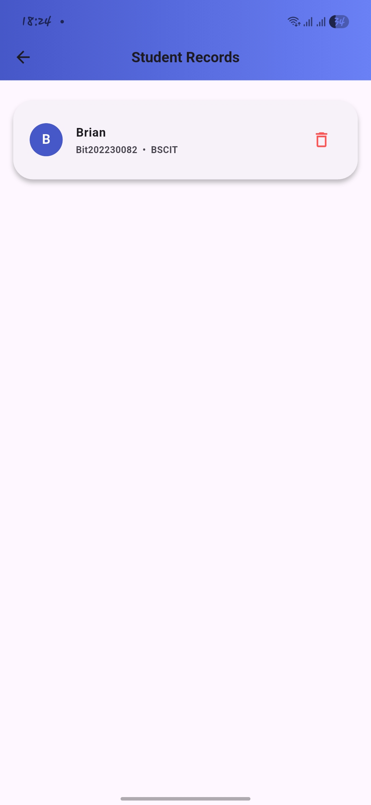

2.2: Tools/Software Used
Flutter , Dart , Android studio

2.3: Personal Reflection
Building CampusFlow was a valuable learning experience. I learned how to integrate Firebase Authentication, work with local storage, design modern and user-friendly interfaces using Flutter, and implement CRUD (Create, Read, Update, Delete) operations. Throughout the project, I overcame challenges such as input validation and gained a better understanding of how to organize and structure scalable Flutter applications. Completing this project improved my development skills and gave me confidence to take on more advanced Flutter projects in the future.

Week 3: User Interface Design

3.1: Practical Activities Undertaken (SCREENSHOTS)
1: Login screen
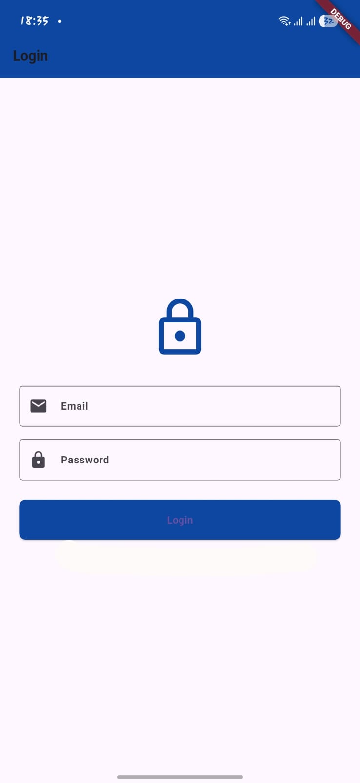

2: dashboard Screen

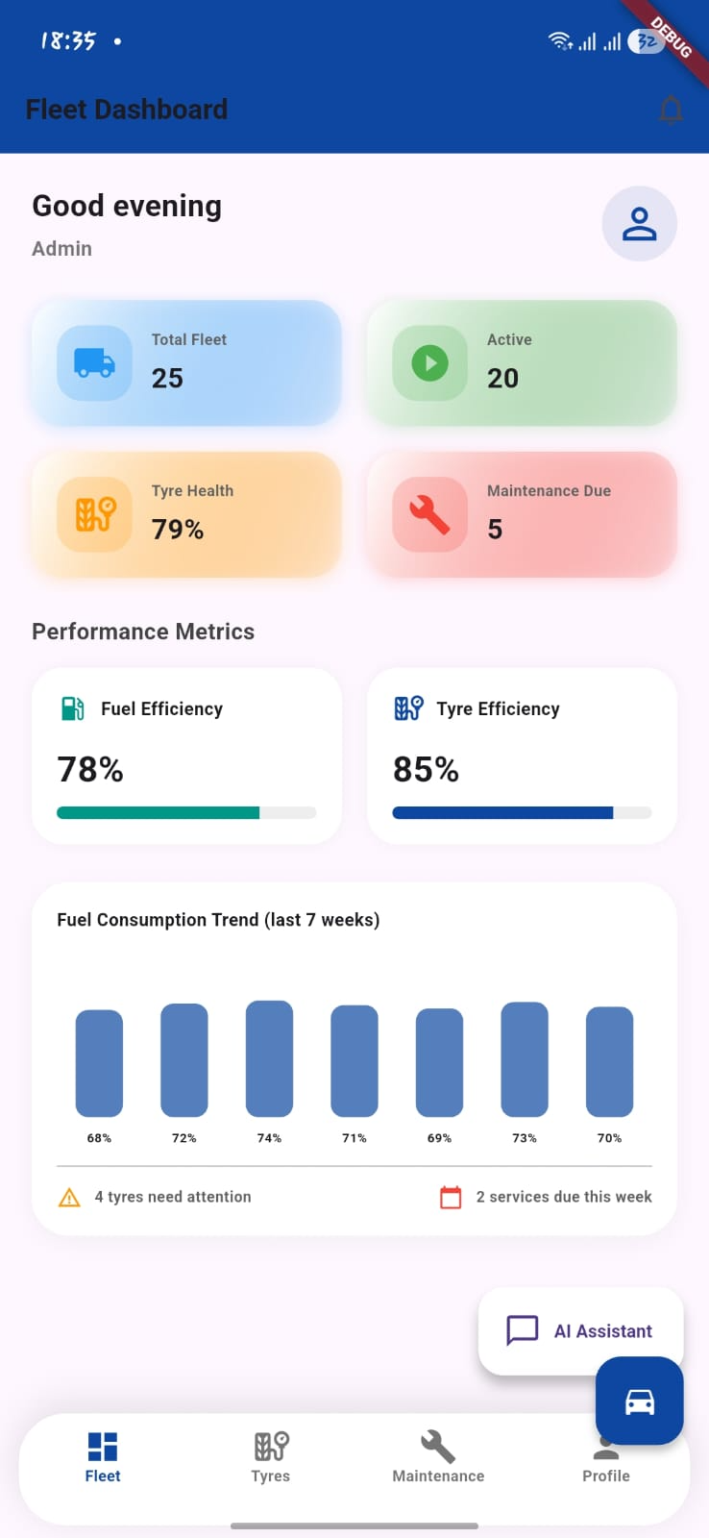

3: Tyre management screen
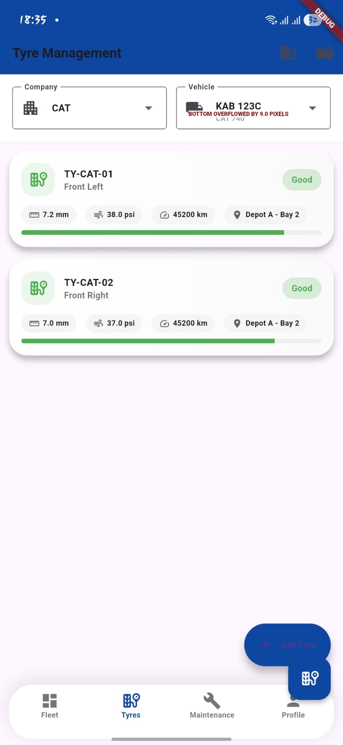

4: Maintenance screen
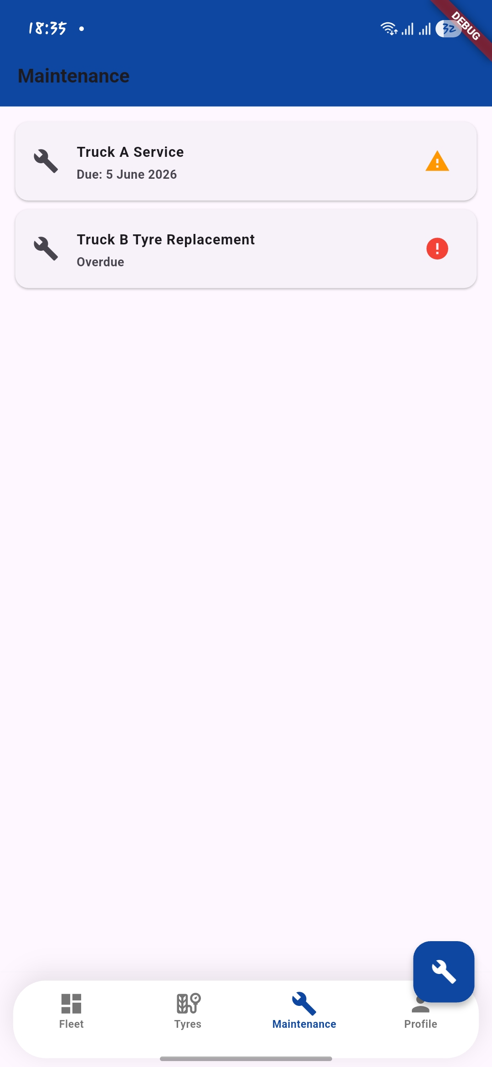

5: Add new tyre
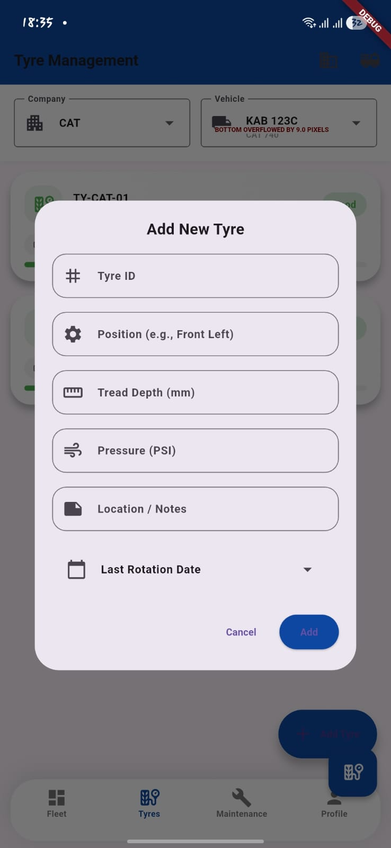

3.2: Tools/Software Used
The CampusFlow system was developed using Flutter 3.0+ and the Dart programming language to create a cross-platform application. Android Studio was used as the primary development environment for coding, testing, and debugging the application. Figma was utilized for designing and prototyping the user interface before implementation. Firebase Authentication was integrated to provide secure user login and authentication services, while Shared Preferences was used for local storage and managing user session data within the application.

3.3: Personal Reflection
Building the PrimeFleet Tyre & Fleet System was a valuable learning experience. I improved my Flutter development skills, learned how to design user-friendly interfaces, implement validation, and organize app navigation effectively. The project increased my confidence in creating practical and professional mobile applications.

